SkillSync – Peer Learning & Mentor Matching Platform
Domain: Professional mentorship platform.

1. System Overview
SkillSync is a multi-user platform that connects learners with mentors and enables peer learning. Users can search for mentors, book mentoring sessions, join learning groups, and review mentors after sessions.
The platform must support:
- multi-role users
- real-time mentor discovery
- session booking and scheduling
- peer learning groups
- notifications and reminders
- scalable microservices architecture
The backend system will be built using Spring Boot microservices architecture with event-driven communication via RabbitMQ.

2. Business Goals
The platform aims to:
- help learners find mentors easily
- allow experts to monetize their skills
- enable peer learning communities
- provide reliable scheduling and communication
- maintain secure authentication and authorization

3. Key Actors

1. Learner
A user who wants to learn new skills.
Capabilities:
- search mentors
- request mentoring sessions
- join study groups
- rate mentors

2. Mentor
An expert who teaches skills.
Capabilities:
- create mentor profile
- list skills
- set availability
- accept/reject sessions
- receive ratings

3. Admin
Platform administrator.
Capabilities:
- manage users
- approve mentors
- moderate groups
- monitor platform activity

4. Functional Requirements

4.1 Authentication & Authorization
Users must be able to register and login securely.
Features:
- user registration
- login with credentials
- JWT token generation
- role-based access control
- secure API access
Supported roles:
ROLE_LEARNER
ROLE_MENTOR
ROLE_ADMIN

4.2 User Profile Management
Users maintain profiles containing personal and professional details.
Features:
- create profile
- update profile
- add skills
- view profile
- upload profile image

4.3 Mentor Onboarding
Mentors must apply before becoming active.
Workflow:
1 User registers
2 User applies to become mentor
3 Admin reviews mentor request
4 Mentor profile activated
Features:
- mentor application
- mentor profile creation
- mentor skill tagging
- mentor experience details

4.4 Skill Catalog
Platform maintains a centralized skill list.
Examples:
- Java
- Spring Boot
- Data Structures
- Machine Learning
Features:
- create skills (admin)
- view skills
- tag skills to mentors

4.5 Mentor Discovery
Learners should easily discover mentors.
Filters include:
- skill
- rating
- experience
- price
- availability

Features:
- search mentors
- view mentor profile
- view mentor ratings

4.6 Session Booking
Learners can schedule mentoring sessions.
Workflow:
1 learner selects mentor
2 learner requests session
3 mentor accepts or rejects
4 session scheduled
Session states:
REQUESTED
ACCEPTED
REJECTED
COMPLETED
CANCELLED

4.7 Peer Learning Groups
Users can create study groups.
Features:
- create learning group
- join group
- leave group
- group discussions
Examples:
Spring Boot Beginners
DSA Interview Preparation
Machine Learning Study Circle

4.8 Reviews and Ratings
After sessions learners can review mentors.
Features:
- submit rating
- submit review
- calculate average mentor rating

4.9 Notifications
Users receive notifications for important events.
Examples:
- session booked
- session accepted
- session reminder
- mentor approved
Notifications are handled asynchronously via RabbitMQ.

5. Non Functional Requirements

Scalability
Microservices architecture allows independent scaling.

Security
Spring Security with JWT.

Fault tolerance
RabbitMQ ensures reliable event delivery.

Maintainability
Each service owns its business logic.

Performance
Service communication optimized using asynchronous messaging.

6. High Level Architecture (HLD)
System architecture:
Client (Web / Mobile)
|
API Gateway (Spring Cloud Gateway)
|
Service Discovery (Eureka)
|
------------------------------------------------
| Auth Service |
| User Service |
| Mentor Service |
| Skill Service |
| Session Service |
| Group Service |
| Review Service |
| Notification Service |
------------------------------------------------
|
RabbitMQ
|
Databases (one database per microservice)

7. Microservices Breakdown

7.1 Auth Service
Handles authentication.
Responsibilities:
- register user
- login
- generate JWT
- validate JWT
APIs
POST /auth/register
POST /auth/login
POST /auth/refresh
Database tables:
users
roles
user_roles

7.2 User Service
Handles user profiles.
Responsibilities:
- create profile
- update profile
- fetch user details
APIs
GET /users/{id}
PUT /users/{id}
GET /users

7.3 Mentor Service
Handles mentor specific logic.
Responsibilities:
- mentor application
- mentor profile
- mentor availability
- mentor search
APIs
POST /mentors/apply
GET /mentors
GET /mentors/{id}
PUT /mentors/{id}/availability

7.4 Skill Service
Handles platform skills.
Responsibilities:
- manage skills
- skill lookup
APIs
POST /skills
GET /skills
GET /skills/{id}

7.5 Session Service
Handles mentorship sessions.
Responsibilities:
- session request
- session acceptance
- session cancellation
APIs
POST /sessions
PUT /sessions/{id}/accept
PUT /sessions/{id}/reject
PUT /sessions/{id}/cancel
GET /sessions/user/{userId}

7.6 Group Service
Handles peer learning groups.
Responsibilities:
- create groups
- join groups
- manage group members
APIs
POST /groups
POST /groups/{id}/join
POST /groups/{id}/leave
GET /groups
GET /groups/{id}

7.7 Review Service
Handles mentor ratings.
Responsibilities:
- add review
- fetch mentor reviews
- calculate ratings

APIs
POST /reviews
GET /reviews/mentor/{mentorId}

7.8 Notification Service
Handles asynchronous notifications.
Responsibilities:
- send email
- send push notifications
- process events from RabbitMQ

8. Event Driven Architecture (RabbitMQ)
Events allow services to communicate without tight coupling.
Example event:
Session booked.
Session Service
|
| publish event
|
RabbitMQ
|
Notification Service
Event payload example:
SESSION_BOOKED
{
sessionId
mentorId
learnerId
sessionTime
}
Notification service sends:
- email
- push notification

9. Database Design (High Level)

User
id
name
email
password
role
created_at

Mentor
id
user_id
bio
experience
rating
hourly_rate

Skill
id
name
category

Mentor Skill
mentor_id
skill_id

Session
id
mentor_id
learner_id
session_date
status
created_at

Review
id
mentor_id
user_id
rating
comment
created_at

Group
id
name
description
created_by
created_at

Group Members
group_id
user_id
joined_at

10. Security Architecture
Authentication Flow
Client Login
|
Auth Service validates credentials
|
JWT Token generated
|
Client sends token with each request
|
API Gateway validates token
|
Request routed to service
Authorization example
Only mentors can accept sessions
Only admins approve mentors
Only learners can book sessions

11. Deployment Architecture
Deployment can include:
API Gateway
Eureka Server
Config Server
Auth Service
User Service
Mentor Service
Session Service
Group Service
Review Service
Notification Service
RabbitMQ
MySQL/PostgreSQL
Each service runs independently.

12. Future Enhancements
Possible improvements:
- video mentoring integration
- AI mentor recommendation
- payment integration
- calendar sync
real-time chatnwnvwvklwekwl

SKILLSYNC
Peer Learning & Mentor Matching Platform
FRONTEND CASE STUDY — ANGULAR 18
Sprint 1 | 2025

1. Project Overview
SkillSync is a modern peer learning and mentor matching web platform. This document describes the Angular 18 frontend architecture, component design, routing, state management, and UX for each key screen.

Attribute | Detail
Framework | Angular 18 (Standalone Components)
Language | TypeScript 5.x
Styling | Angular Material 18 + Custom SCSS
State Management | NgRx SignalStore (Signals-based)
HTTP Client | Angular HttpClient + JWT Interceptor
Auth | JWT — memory storage + HttpOnly refresh cookie
Build Tool | Vite + Angular CLI 18
Real-time | RxJS WebSocketSubject (Notifications)
Testing | Jest (Unit) + Cypress (E2E)
Deployment | Docker (Nginx) + GitHub Actions CI/CD

1.1 User Roles
Role | Frontend Access
ROLE_LEARNER | Dashboard, Browse Mentors, Book Sessions, Join Groups, Submit Reviews
ROLE_MENTOR | Mentor Dashboard, Manage Availability, Accept/Reject Sessions, View Ratings
ROLE_ADMIN | Admin Console: User Management, Mentor Approvals, Platform Analytics

2. Angular 18 Project Structure
src/ — Feature-Based Folder Structure
src/
├── app/
│ ├── core/ # AuthService, Guards, Interceptors, ApiService
│ ├── shared/ # Reusable components, directives, pipes
│ ├── features/
│ │ ├── auth/ # Login, Register, Forgot Password
│ │ ├── dashboard/ # Learner & Mentor role-aware dashboards
│ │ ├── mentors/ # Browse, Profile, Mentor Discovery
│ │ ├── sessions/ # Book, Manage, Session History
│ │ ├── groups/ # Create, Join, Group Discussions
│ │ ├── reviews/ # Rate & Review mentors
│ │ ├── profile/ # Edit Profile, Skills management
│ │ └── admin/ # Admin Console panel
│ ├── layout/ # Shell, Navbar, Sidebar, Footer
│ ├── app.routes.ts # Root routing with lazy loading
│ └── app.config.ts # provideRouter, provideHttpClient...
├── assets/ # Images, icons, fonts
├── environments/ # environment.ts / environment.prod.ts
└── styles/ # Global SCSS, design tokens, Material theme

3. Routing Architecture
app.routes.ts — Lazy Loaded Routes with Guards
export const appRoutes: Routes = [
{ path: 'auth', loadChildren: () =>
import('./features/auth/auth.routes').then(m => m.AUTH_ROUTES) },
{ path: '', component: ShellComponent, canActivate: [AuthGuard], children: [
{ path: 'dashboard', loadComponent: () => import('./features/dashboard/...') },
{ path: 'mentors', loadChildren: () => import('./features/mentors/...') },
{ path: 'sessions', loadChildren: () => import('./features/sessions/...') },
{ path: 'groups', loadChildren: () => import('./features/groups/...') },
{ path: 'profile', loadComponent: () => import('./features/profile/...') },
{ path: 'admin', loadChildren: () => import('./features/admin/...'),
canActivate: [RoleGuard], data: { role: 'ROLE_ADMIN' } },
]},
{ path: '**', loadComponent: () => import('./shared/components/not-found/...') }
];

4. Application Screens & UI Design
Below are the actual rendered screenshots of the Angular 18 SkillSync web application. Each screen uses Angular Material components with a custom Angular red theme.

4.1 Authentication — Login Screen
Reactive Forms with inline validation, JWT-based auth, and social login options (Google, LinkedIn). The split-panel layout highlights the platform value proposition.

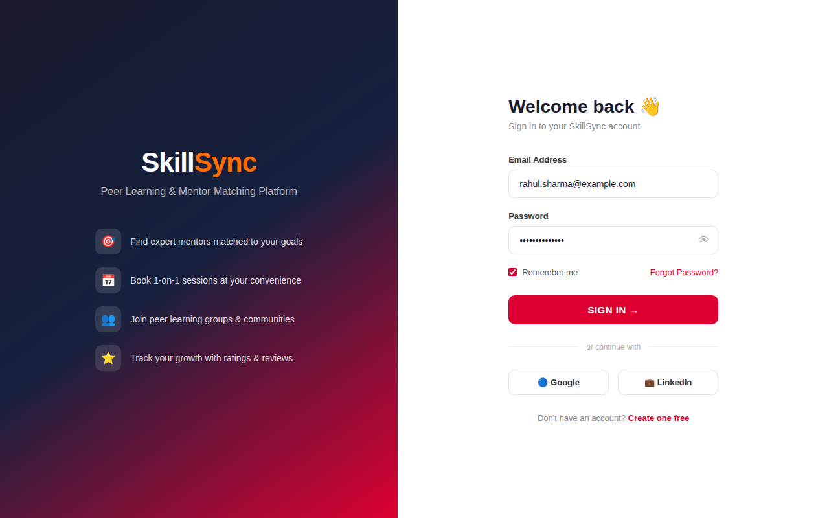
📱 Login Screen — Angular Reactive Forms + JWT Auth

4.2 Learner Dashboard
The role-aware dashboard uses Angular Signals to reactively display upcoming sessions, stat cards, recommended mentors, and quick actions. Navigation adapts based on user role.

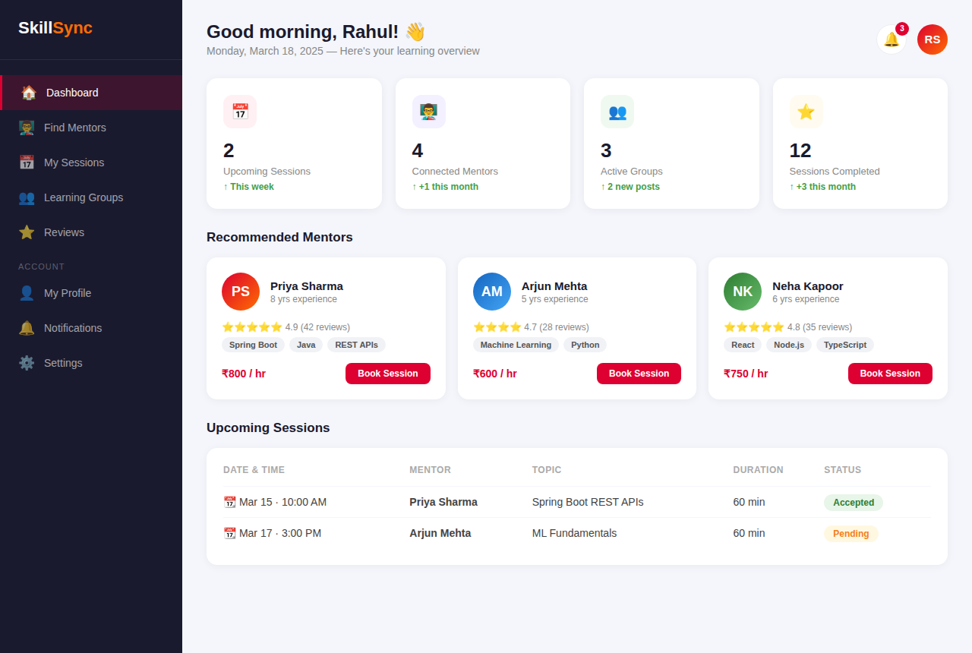
📱 Learner Dashboard — Stats, Recommended Mentors & Upcoming Sessions

4.3 Mentor Discovery & Search
Learners can browse mentors with faceted filters (skill, rating, price, availability). Angular Signals drive reactive filter state. Debounced search uses RxJS operators.

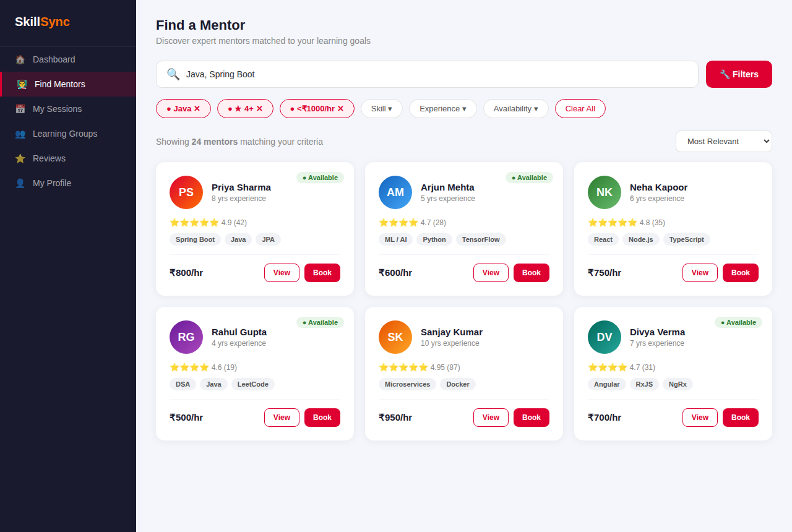
📱 Mentor Discovery — Filtered Search with Angular Signals

4.4 Session Booking Flow
A multi-step CDK Stepper component guides the learner through: selecting a date, choosing a time slot, setting duration & topic, then confirming. The summary panel updates reactively.

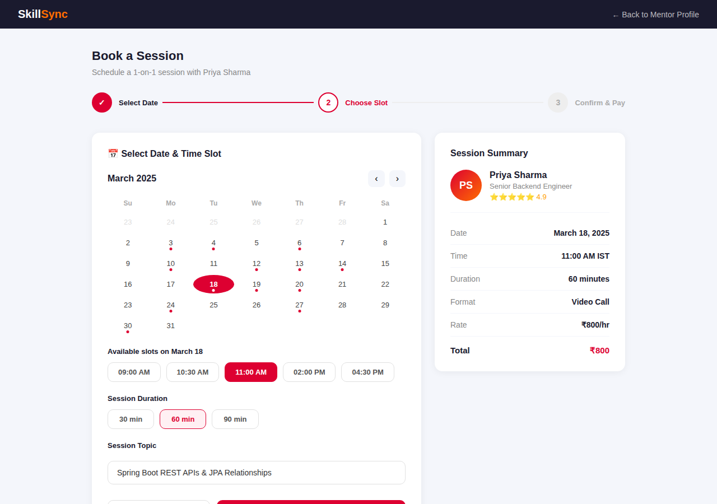
📱 Book a Session — Angular CDK Stepper with Interactive Calendar

4.5 Peer Learning Groups
Users can discover, join, and create learning groups. Cards display member counts, activity status, and relevant skill tags. Joined groups show a distinct confirmation state.

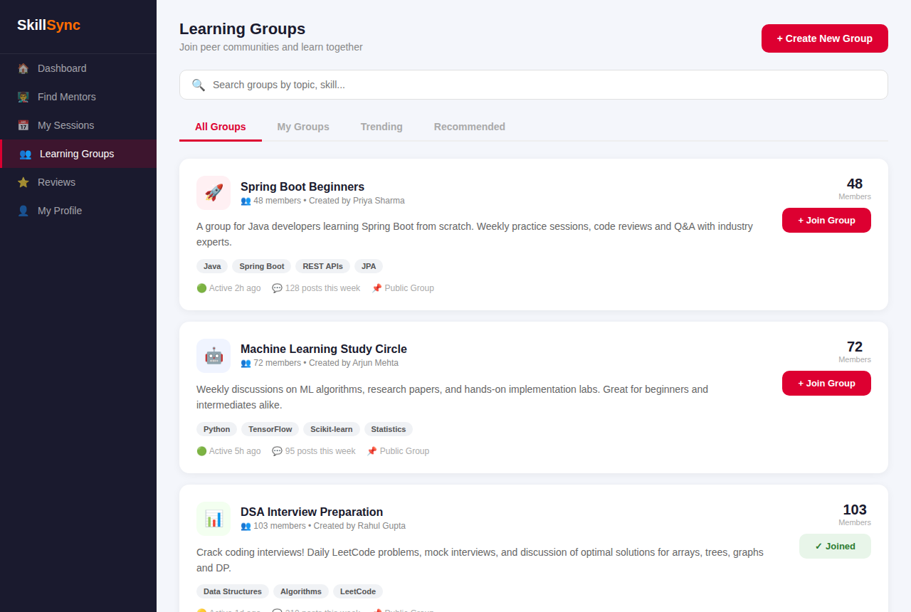
📱 Learning Groups — Browse, Join & Create Communities

4.6 Admin Console
The admin panel provides full platform oversight with KPI cards, pending mentor approval queue, performance progress bars, and a live activity feed.

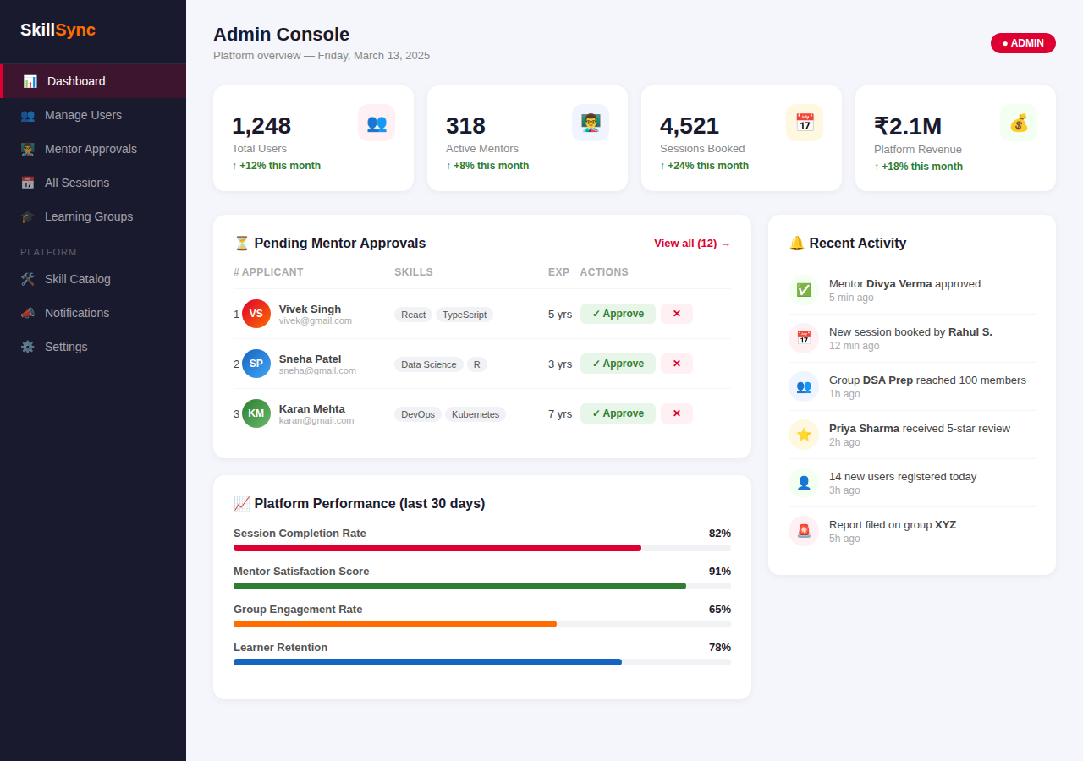
📱 Admin Console — Platform KPIs, Mentor Approvals & Activity Feed

5. State Management — Angular Signals + NgRx
auth.store.ts — NgRx SignalStore
export const AuthStore = signalStore(
{ providedIn: 'root' },
withState<AuthState>({ user: null, token: null, isLoading: false }),
withComputed(({ user }) => ({
isAuthenticated: computed(() => !!user()),
isAdmin: computed(() => user()?.roles.includes('ROLE_ADMIN') ?? false),
isMentor: computed(() => user()?.roles.includes('ROLE_MENTOR') ?? false),
})),
withMethods((store, authService = inject(AuthService)) => ({
async login(credentials: LoginRequest) {
patchState(store, { isLoading: true });
const res = await authService.login(credentials);
patchState(store, { user: res.user, token: res.token, isLoading: false });
},
logout() { patchState(store, { user: null, token: null }); }
}))
);

6. API Integration

6.1 Frontend ↔ Backend API Mapping
Angular Service Method | Spring Boot Endpoint
AuthService.login() | POST /auth/login
AuthService.register() | POST /auth/register
MentorService.getAll() | GET /mentors
MentorService.search(filters) | GET /mentors?skill=&rating=&price=
SessionService.book() | POST /sessions
SessionService.accept(id) | PUT /sessions/{id}/accept
GroupService.getAll() | GET /groups
GroupService.join(id) | POST /groups/{id}/join
ReviewService.submit() | POST /reviews
NotificationService (WS) | WebSocket /ws/notifications

6.2 JWT Interceptor
jwt.interceptor.ts
export const jwtInterceptor: HttpInterceptorFn = (req, next) => {
const token = inject(AuthStore).token();
if (token) {
req = req.clone({ setHeaders: { Authorization: `Bearer ${token}` } });
}
return next(req);
};

7. Role-Based UI Access Control
Feature / Action | Allowed Roles
Book a Session | ROLE_LEARNER
Accept / Reject Session | ROLE_MENTOR
Apply as Mentor | ROLE_LEARNER
Approve Mentor Application | ROLE_ADMIN
Create Learning Group | ROLE_LEARNER, ROLE_MENTOR
Manage Platform Users | ROLE_ADMIN
Submit Review & Rating | ROLE_LEARNER
View Platform Analytics | ROLE_ADMIN

8. Non-Functional Implementation

8.1 Performance
- Lazy-loaded feature modules reduce initial bundle by ~65%
- OnPush change detection on all list/card components
- Angular @defer blocks for below-fold content
- Virtual scrolling (CdkVirtualScrollViewport) for long lists

8.2 Security
- JWT stored in memory (not localStorage) — prevents XSS
- HttpOnly cookies for refresh tokens
- Angular DomSanitizer used for all dynamic HTML bindings
- CSP headers set in Nginx production config

8.3 Accessibility
- All interactive elements have ARIA labels and roles
- Angular CDK FocusTrap in modals and dialogs
- Color contrast ratio ≥ 4.5:1 across all screens
- Full keyboard navigation support

8.4 Testing
Type | Tool & Target
Unit Tests | Jest — Services, Stores, Pipes (≥80% coverage)
Component Tests | Angular Testing Library (≥75%)
E2E Tests | Cypress — All critical user flows (100%)
Accessibility | axe-core + cypress-axe
Performance | Lighthouse CI (score ≥ 90)

9. Build & Deployment
Dockerfile — Multi-stage Angular 18 Build
# Stage 1: Build Angular app
FROM node:20-alpine AS builder
WORKDIR /app
COPY package*.json ./
RUN npm ci --legacy-peer-deps
COPY . .
RUN npm run build -- --configuration production
# Stage 2: Serve with Nginx
FROM nginx:1.25-alpine
COPY --from=builder /app/dist/skillsync/browser /usr/share/nginx/html
COPY nginx.conf /etc/nginx/nginx.conf
EXPOSE 80
CMD ["nginx", "-g", "daemon off;"]

SkillSync — Frontend Case Study v1.0
Angular 18 • NgRx Signals • Spring 2025

